Our popular Winter Fix Program is back!
Save 5% or MORE on LABOUR and PARTS that we install when you call before December 31st to schedule a maintenance inspection and have us complete the work on your approval.
Schedule (1) maintenance inspection and save 5%
Schedule (2) maintenance inspections and save 15%

Now’s the time to call us and book an appointment

Bob Mark’s service teams are here to help and whether you need to schedule a service inspection, an oil change on a compact tractor, rebuild an engine on a larger tractor, inspect and complete approved repairs on a baler, mower conditioner, excavator or skid steer we have the people, skills and tools to get the job done!

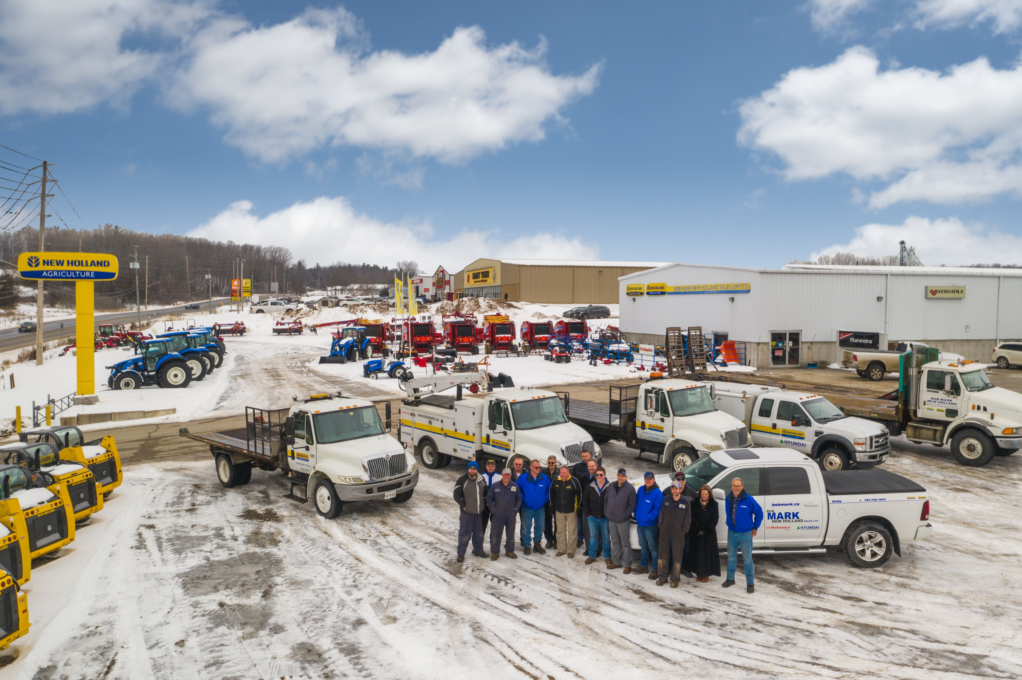

Sunderland (705) 357-3121 Lindsay (705) 324-2221
Cory Geissberger – Service Manager Ken Buckley – Service Manager

Campbellford (705)653-3700 Napanee (613) 354-9244
Adam Cam – Service Manager Bret Outram - Service Manager

Our dealerships and service staff have more than 145 years of experience……. How can we Help You? 😊

